I chose three Western Media channels which are:

**CNN (London):** <https://edition.cnn.com/2022/11/13/europe/istanbul-turkey-explosion-intl/index.html>

**Reuters:** <https://www.reuters.com/world/middle-east/central-istanbul-blast-leaves-multiple-wounded-media-video-2022-11-13/>

**Washington Post:** <https://www.washingtonpost.com/world/2022/11/13/istanbul-turkey-explosion-istiklal/>

CNN:

They are taken quotes from Fuat Oktay (vice president):

- “We consider it to be a terrorist act as a result of an attacker, whom we consider to be a woman, detonating the bomb,”

They are taken quotes from Süleyman Soylu:

- “It is PKK/PYD terrorist organization according to our preliminary findings,”

- “A little while ago the person who left the bomb (was) taken under custody by teams of Istanbul Police Department. Before their arrest 21 more people were also taken under custody,”

- “The face of terrorism is bitter, but we will continue this struggle to the end, whatever the cost is.”

-“In particular, the insincerity of our so-called allies who seem friendly to us, who either hide terrorists in their own country, or feeds terrorists in the areas they occupy and send them money from their own senates, is obvious,”

-“We will give them a response in the near future, to those who caused us this pain in Beyoglu Istiklal Street so they experience more and more pain,”

They are taken quotes from Bekir Bozdağ:

-“There are two possibilities. Either that bag or plastic bag has a mechanism in it, it explodes on its own or someone detonates it from afar. All of these are currently under investigation.”

-“The name of the woman is unknown. All the recordings and data about the woman are being analyzed.”

They are taken quotes from Ali Yerlikaya (Istanbul Governor):

-“We wish God’s mercy on those who lost their lives and a speedy recovery to the injured,” (This is a tweet)

They also took quotes from a foreign withness:

-“People were scattering immediately,”

-“Very shortly after, I could see how many injured were on the ground,”

-“There was a man in the store bleeding from his ears and his legs, and his friends were crying near him,”

They are also taken quotes from Stolenberg, Macron, European Council President Charles Michel, Ukrainian President Volodymyr Zelensky, White House Press Secretary Karine Jean-Pierre.

They elaborate the situation by using tragedic photographs. They frequently used the police phenomenon and chose a non-Turkish person as a witness. They have allocated as much space to the reaction and messages of the West as the event itself. They feel that Süleyman Soylu's explanation of the incident is inadequate. They told the story in phrases such as severed legs, arms, and people hugging and crying, all of which kept the tragedy in the foreground.

The images are consistent with the texts as far as I have researched. Usually the photos were taken by Turks working for big news organizations. The video in the Reuters news was used. I could not find data on how many people read and commented on the news.

CNN used these audiovisuals in the news.

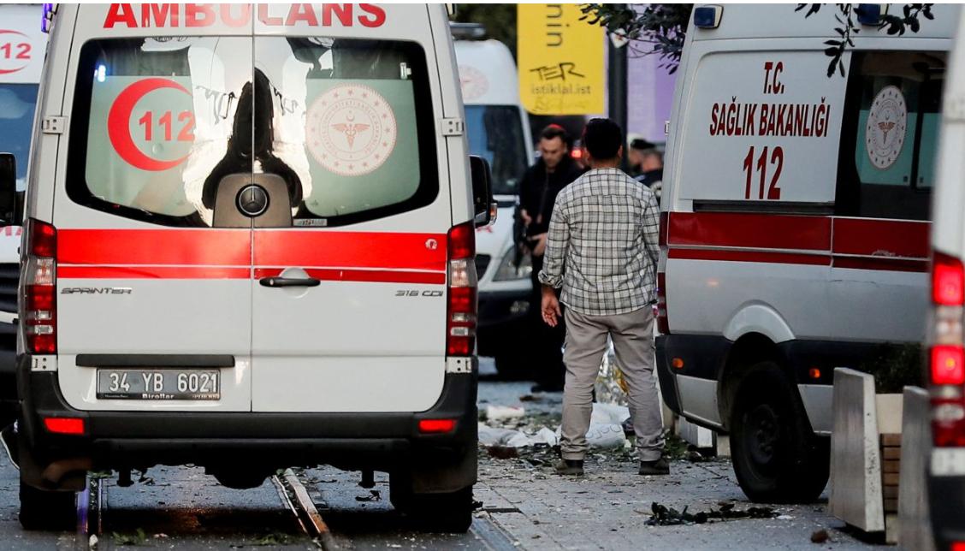

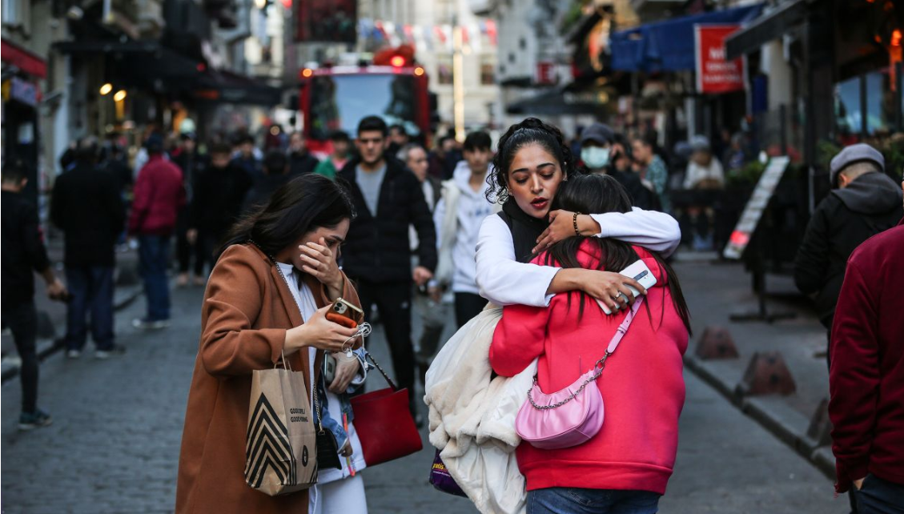

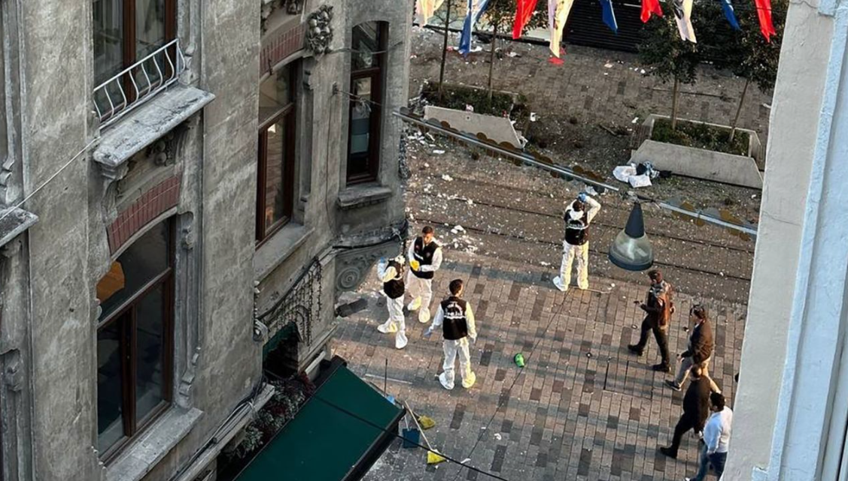

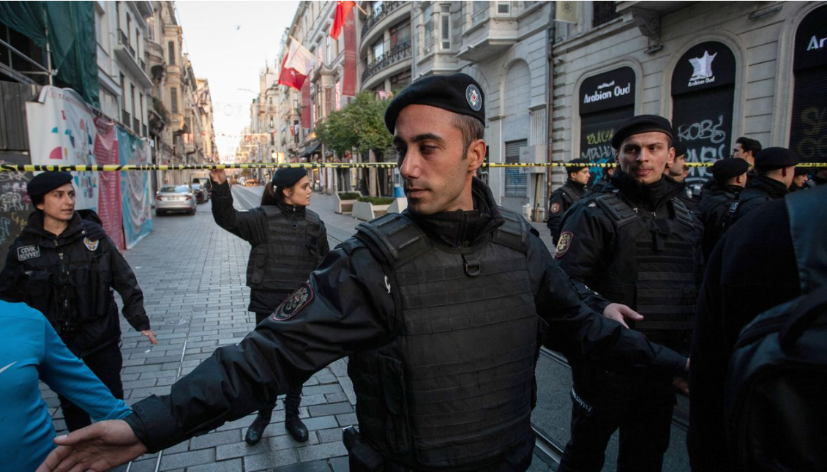

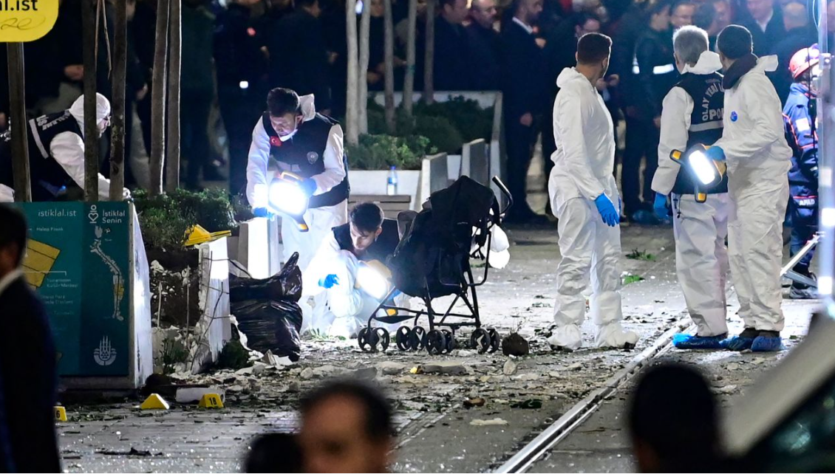

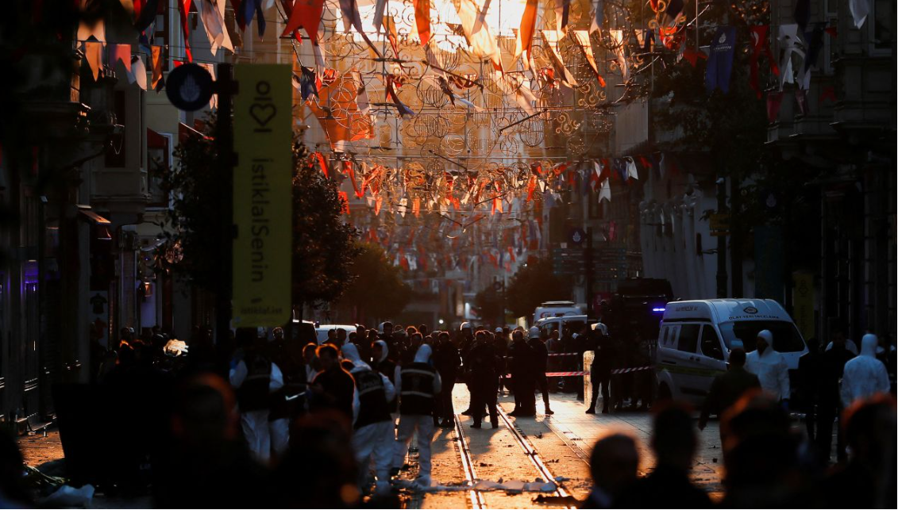

Washington Post:

There are 111 comment for this news. In the Washington post news, he talked about the media ban and Soylu's threats against the PKK rather than the incident itself. Both the photographs they used and the words quoted were arranged in such a way that it could be understood that there was chaos in Turkey. If the same event had been in a western country, it would have been written with so much condemnation, but it was intended to show more countries in chaos for turkey. Istiklal is described as Istanbul's Champs-Élysées. Explaining two positions that can be seen with the same status in this way may indicate the effort of the western media to marginalize. In the comments, it is possible to see criticisms about this style and the attitude of the West. Of course, there are also opposing views.

Washington post used these visuals in the news.

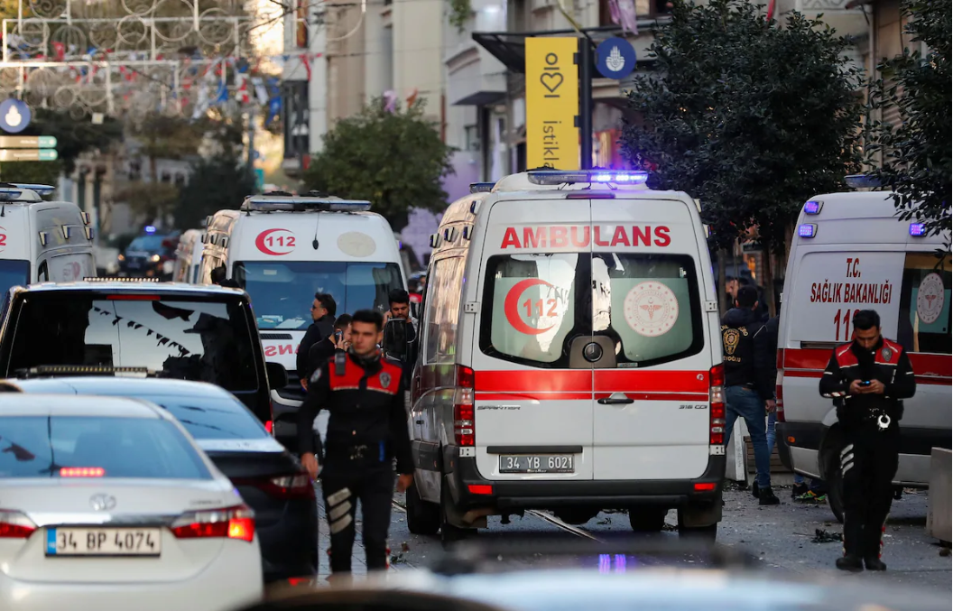

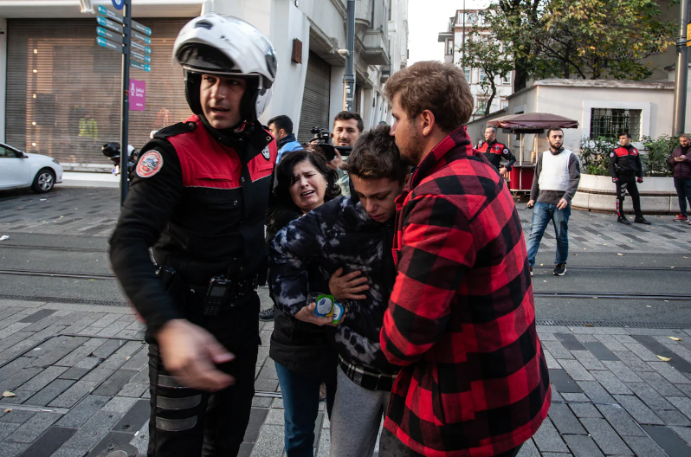

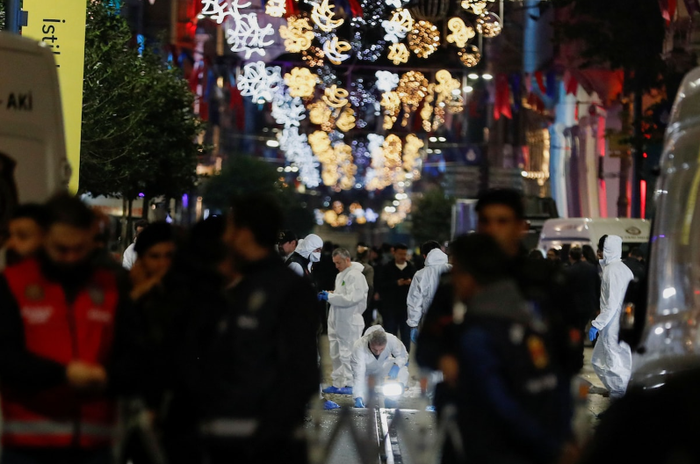

Reuters:

Referring to the attacks in 2015-2016, Reuters mentioned that two of the dead were a ministry employee and his daughter. They took the quotes mentioned under the CNN heading in the same way. Besides, it is possible to see a quote from a Turkish eyewitness. ("When I heard the explosion, I was petrified, people froze, looking at each other. Then people started running away. What else can you do," said Mehmet Akus)

Other countries expressing their condolences were also mentioned in this article. The news, which has a visually richer content than the others, again draws attention to the police, ambulance, people shouting, crime scene investigation teams. (Other sources often use Reuters images anyway.)

In addition, there is another article about police violence in the "more from retuers" section under this article on the Reuters page. I think this is also a factor to consider. The phrase "People froze" is written in large fonts like a headline and used to enhance the effect of the event. I could not reach the number of people who read and comment on this news.